PENETRATION TESTING REPORT
Penetration testing report for CTF called Vikings 1 from VulnHub

12 AUGUST 2026
AUTHOR: SZYMON STEFAŃSKI
CLASSIFICATION: EDUCATIONAL
ENVIRONMENT: CONTROLLED ISOLATED LAB
VERSION: 1.0

Statement Of Confidentiality
The contents of this document have been developed by Szymon Stefański as a part of the educational path towards penetration tester carrier. This document presents the full process of capturing flags ( user and root ) inside of a vulnerable machine called Vikings 1.
All contents of this document that will be used outside of its legal purposes and educational functions will be considered an illegal activity that the author does not take responsibility for.

Contents
Statement Of Confidentiality 2
Executive Summary 4
Approach 4
Scope 4
Assessment Overview and Recommendation 4
Penetration Test Assessment Summary 4
Summary of Findings 5
Compromised System Walkthrough 5
Detailed Walkthrough 6
Enumeration / information gathering 6
Initial Access 6
Exploitation 6
Reproduction of the steps 7
Remediation Summary 14
Mitigation 14
References 15

Executive Summary
This document demonstrates the process of capturing two flags inside of a vulnerable machine called Vikings 1, which can be downloaded from VulnHub.

Approach
I performed testing under a „black box” approach on August 12 2026 without any credentials or advance knowledge about source code or the target. Testing was performed using a Kali Linux attack machine inside an isolated host-only network in VirtualBox. The goal was to find the flags inside of the machine through enumeration, steganography and exploitation of vulnerable software and misconfiguration.

Scope
The scope of this assessment was one internal network range with two open ports and virtual machine access. Target machine was running on Ubuntu 18.04.5.
Host/URL/IP Address | Overview
192.168.239.10 | Vikings1 machine IP address
192.168.239.10:80 | Apache 2.4.49 server over http
192.168.239.8:22 | OpenSSH server

Assessment Overview and Recommendation
During the internal penetration test against Vikings 1 I managed to find several issues that I categorized and described by severity level.
The first thing that I noticed during directory enumeration was a hidden file containing the location of the, encoded with Base64 format, .zip file. Due to this finding, I was able to eventually decode the archive and crack the password required for it to open.
The second founding was inside of the mentioned archive. After getting access to its content I found an image file with hidden binary data, containing information about both username and password of one of the accounts on the target machine.
Lastly, after gaining access to the account I noticed two things. First was lack of permission restriction on the other account, allowing me to read the user flag from the second user’s home directory. Second was the LXD privilege group for the first account, which allowed me to perform an LXD privilege escalation attack.

Penetration Test Assessment Summary
During testing I started as an unauthenticated user with no such information as configuration information, source code, files or users.

Summary of Findings
During the course of testing, I uncovered a total of 5 findings that posed a risk for the system of Vikings1. The below table provides a summary of the findings by severity level.
Findings
High | Medium | Low
2 | 2 | 1

Below is a high-level overview of each finding identified during testing. These findings are covered in depth in the Technical Findings Details section of this report.
# Findings | Severity Level | Finding Name
1 | Medium | Hidden encoded file
2 | Medium | Weak archive password
3 | High | Credentials in an image file
4 | Low | World-readable user.txt
5 | High | LXD privilege escalation

NOTE!: While findings 1-3 are scored individually, they form a sequential attack chain. The combined impact effectively grants unauthorized SSH access to the target system, which would warrant a combined severity rating of High ( 7.5+ ).

Compromised System Walkthrough
During my testing of the assessment I was able to find war.txt and through it the war-is-over file containing base64 encoded zip file, that was password protected. After modifying the file with zip2john I cracked the password and received the contents, which turned out to be an ASCII file with credentials of Floki’s account.
After logging in as user Floki, I noticed that there is another user called Ragnar. There was a hint and mathematical task ( Collatz Conjecture ) to resolve. With the task done, I got a decimal cipher that turned out to be Ragnar’s password. However, I was able to read the flag from Rangar’s directory as Floki and abuse system configuration on that account due to LXD group privilege and escalate to root for the final flag.Steps below demonstrate processes of information gathering / enumeration, initial access, exploitation, privilege escalation and post-exploitation.
NOTE!: LXD is a system container and virtual machine manager that acts as a REST API front-end for the Linux kernel's virtualization features ( called LXC ). It can be abused for local privilege escalation if a low-privilege user belongs to the local lxd group, because group members can instruct the root-backed LXD daemon to mount the host's entire filesystem inside a privileged container.

Detailed Walkthrough

Enumeration / information gathering
- Using netdiscover -i <interface> -r 192.168.239.0/24 to scan my host-only network to get the IP address of the target machine ( 192.168.239.10 ).
- I used the standard nmap command for port scanning: nmap -sV -sC 192.168.239.10. It revealed two open ports with SSH and Apache servers and /site page on port 80.
- During directory enumeration with gobuster command : gobuster dir -u “192.168.239.10/site/” -k -w /usr/share/wordlists/dirbuster/directory-list-2.3-small.txt -t 64 -x .php,.txt,.js,.bck,.backup I found war.txt file, that had information about another hidden file war-is-over that contained base64 encoded message, which turned out to be a zip file ( or generally an archive ).

Initial Access
- I downloaded the file using curl “http://192.168.239.10/site/war-is-over/” | base64 -d > output command and check the file type with file command. It was AES encrypted zip archive data.
- Using zip2john I transformed the output file into a john readable file named war and proceeded with cracking the password with john - -wordlist=/usr/share/wordlists/rockyou.txt war . I received the password “ragnar123” and could now open the archive using the 7z x output command.
- Zip archive data was hiding an image file named king. I used exiftool to read the metadata for clues, but did not find anything interesting. However, with the binwalk -e king command I found hidden binary data, that was a file with credentials for user ‘floki’. Thanks to this finding I could access the account using SSH.

Exploitation
- Using the stolen credentials, I logged in as floki user. After moving around I noticed that I could read the user flag file from /home/ragnar directory, suggesting lack of permission restriction for this file. I did find the hint and suggestion to resolve the Collatz Conjecture math problem for this task and I decipher the result to retrieve the rangar’s password, but I found another way to escalate to root.
- When I was moving around both user accounts, I found out that floki has LXD privilege to run virtual containers on Linux machine. I’ve read that it creates a possible LXD privilege escalation vulnerability, that I proceeded to use.
- Following exploit-db code for this exploit, I created a file ‘exploit’ on floki’s account and using sftp floki@192.168.239.10 I moved and downloaded the Alpine build file from github, following the instructions from the code.
- With files ready with proper execute permissions, I ran the ./exploit -f alpine-v3.24-x86_64-20260812_2022.tar.gz and create a virtual container with root privileges and all resources from the host machine under /mnt/root directory. With access acquired, I’ve read the root flag.

Reproduction of the steps
Using nmap and netdiscover I found information about the target and its active services.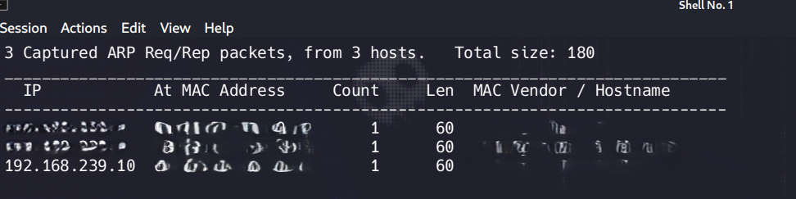
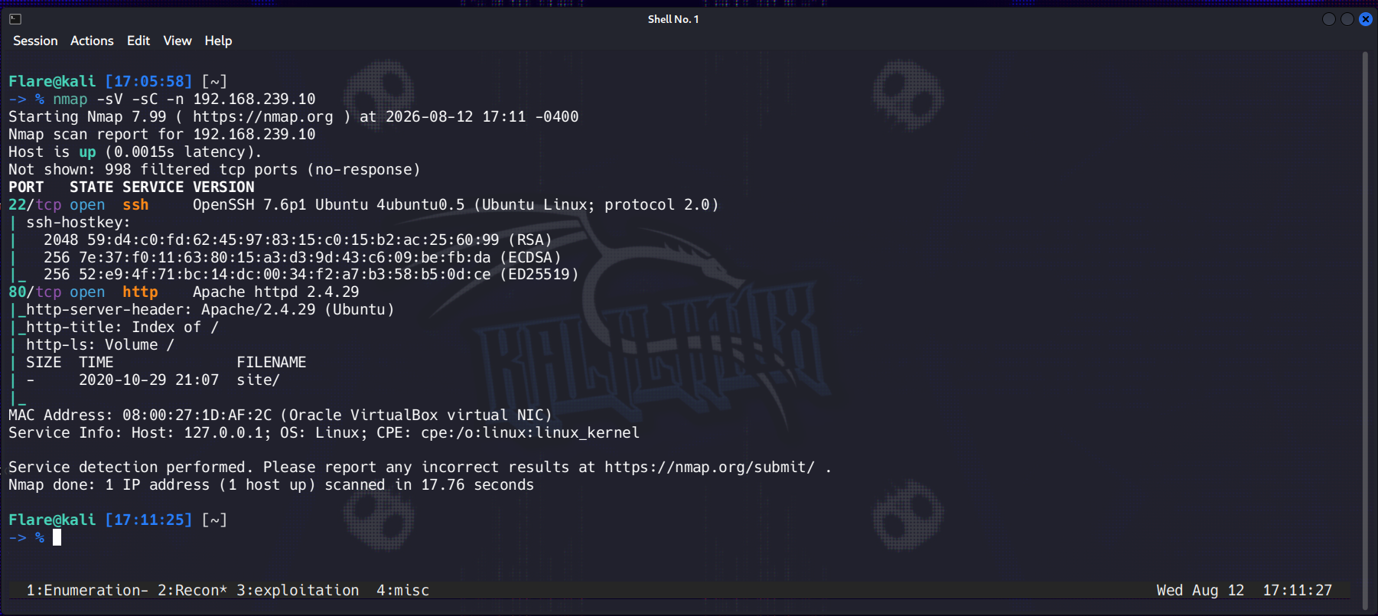
With gobuster I enumerated through the directories of /site page and found the war.txt file.
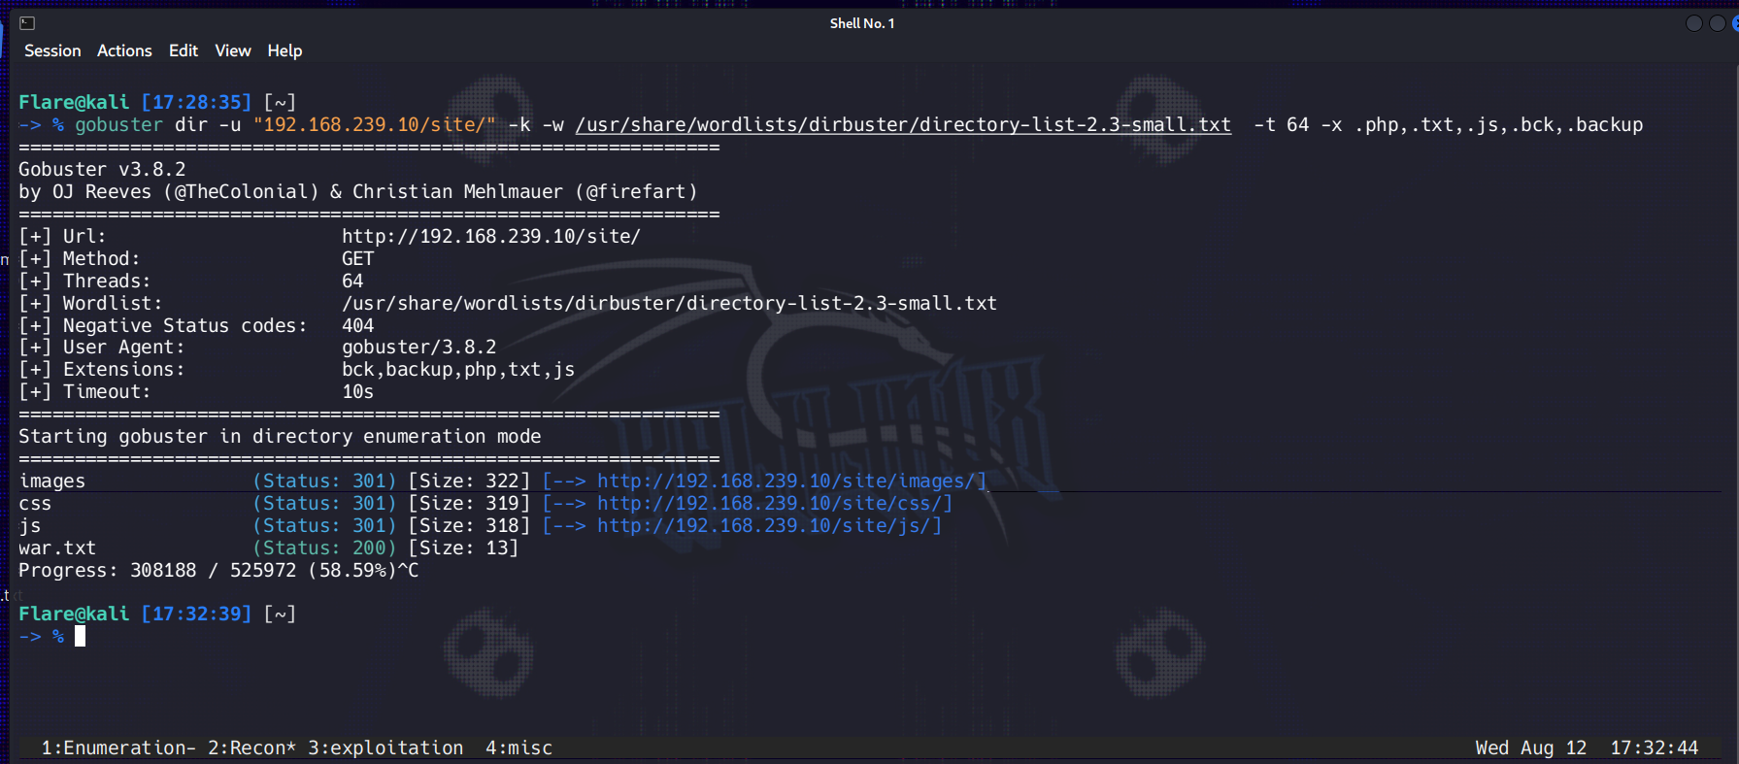
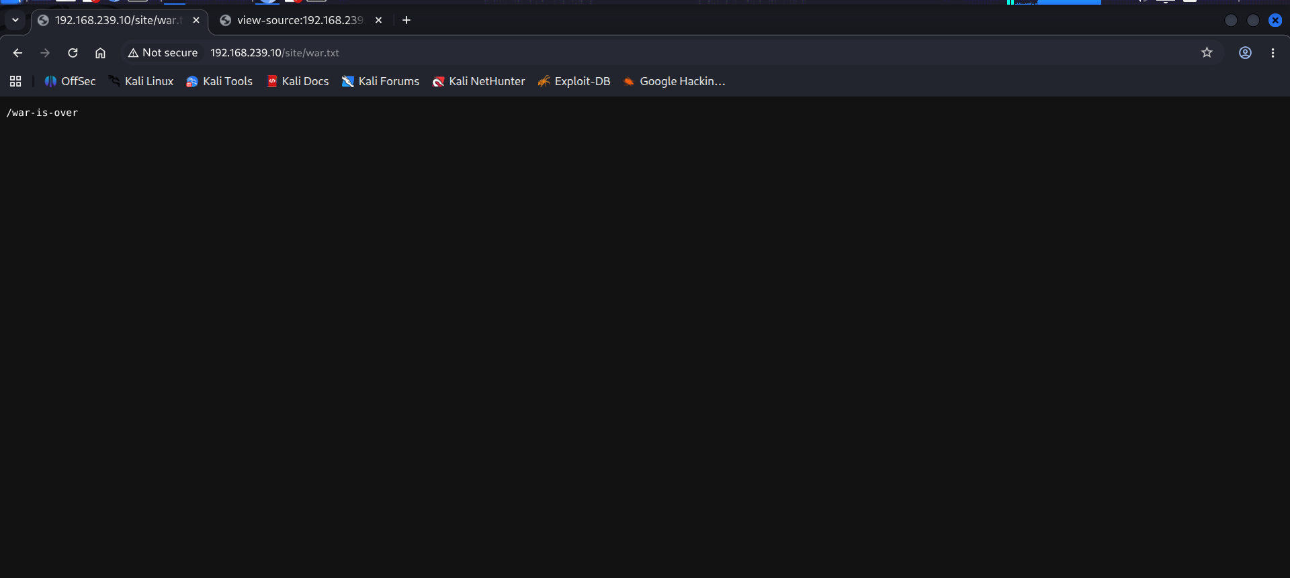
With curl, I downloaded contents from the war-is-over file and decoded it as an ‘output’ file, which turned out to be zip archive data.
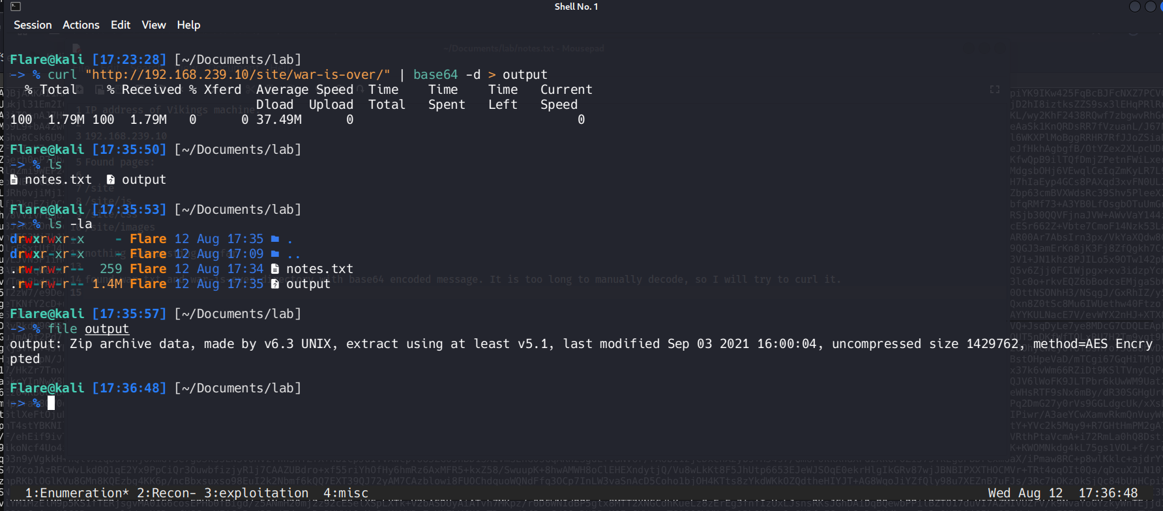
With the john and zip2john option I cracked the password ( ragnar123 ) needed to open the file and retrieved the ‘king’ image file.
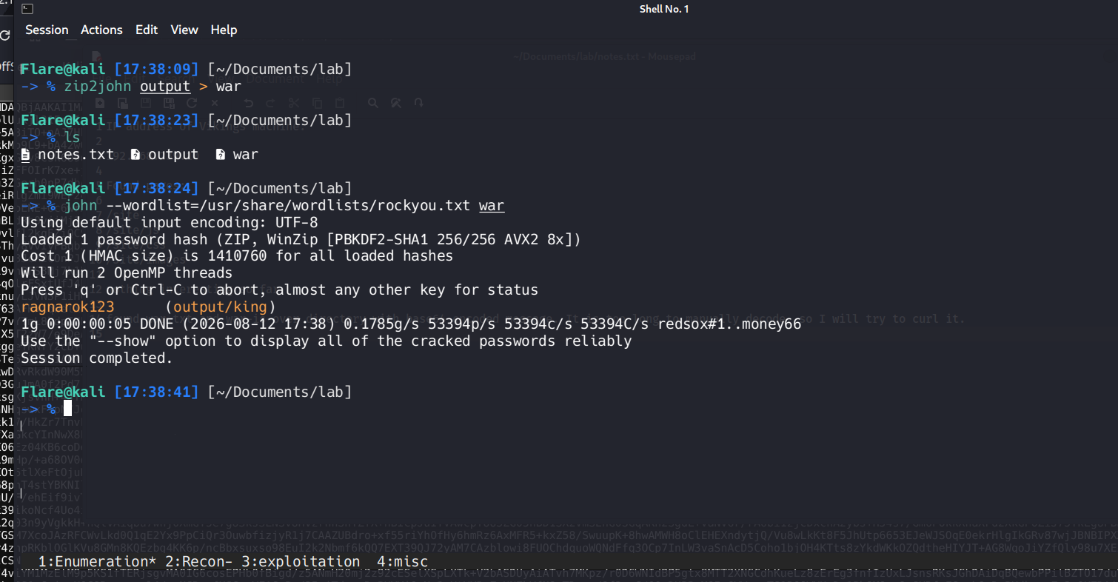
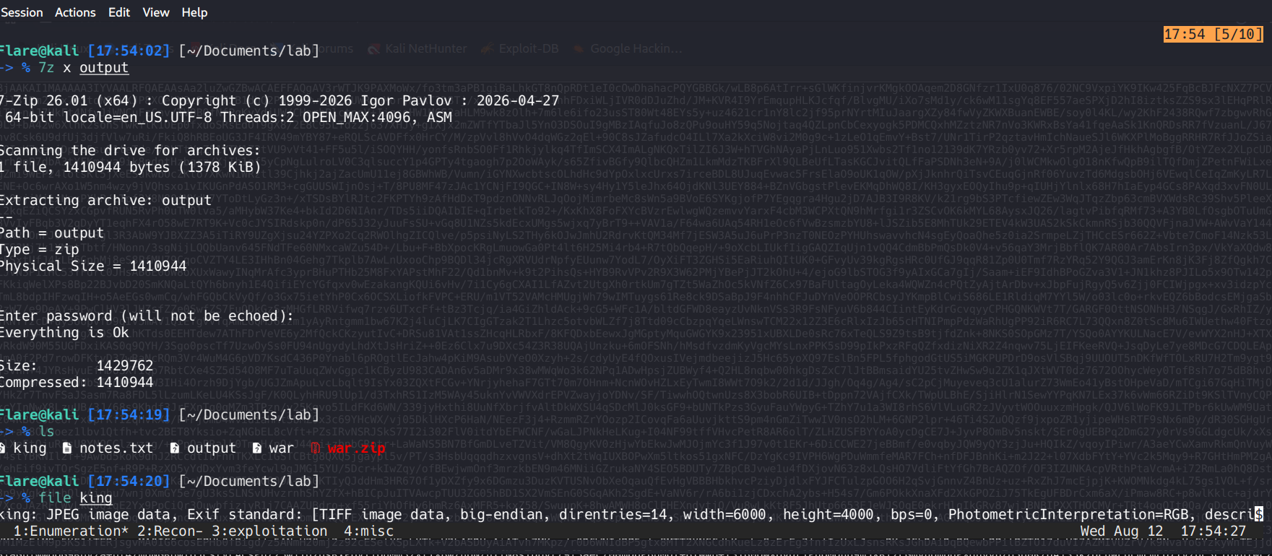

While the exiftool did not find anything interesting, with binwalk I discovered hidden binary data that contained credentials for user floki.
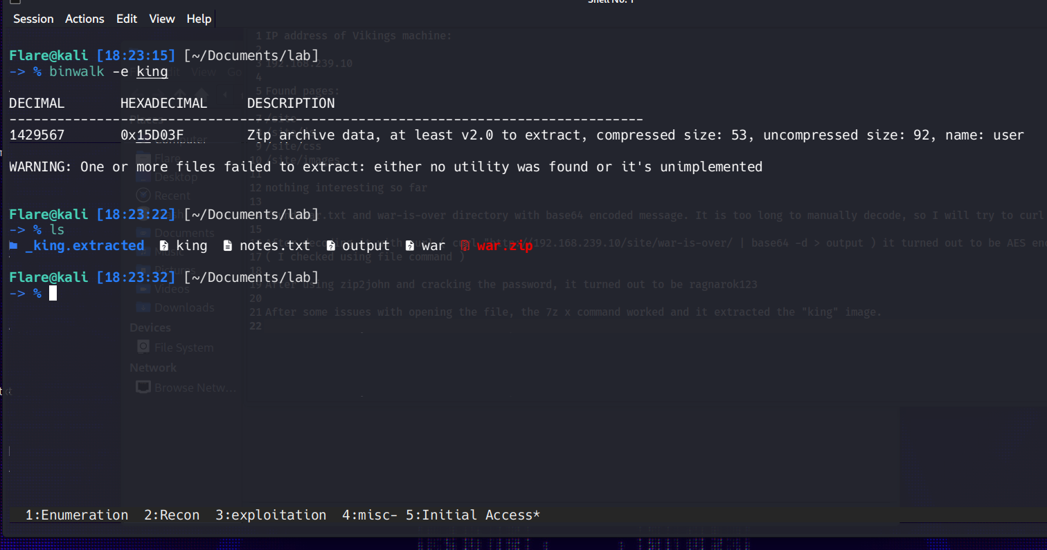
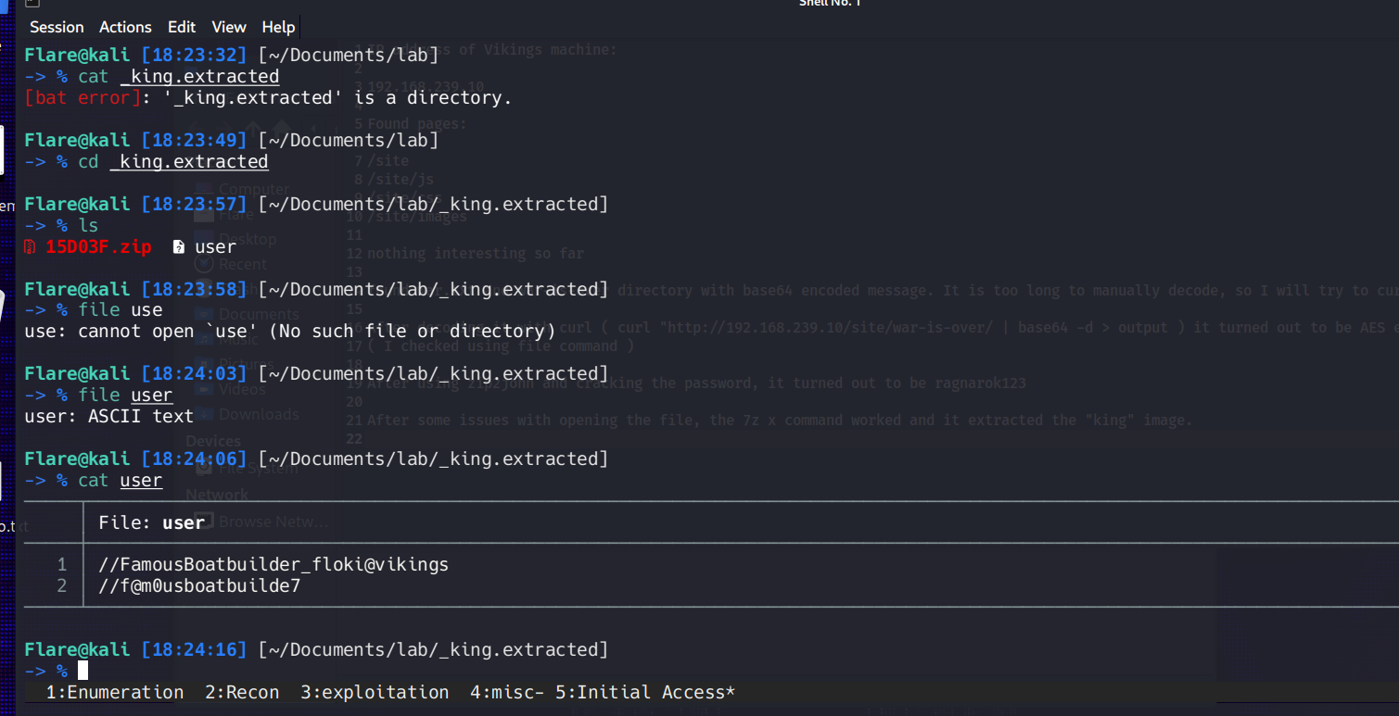
As mentioned, I happened to find out that the user.txt flag is readable by floki, despite being placed in ragnar’s home directory. Meaning I could skip the mathematical task, but below I’ll leave what I found about rangar’s password.
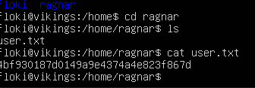
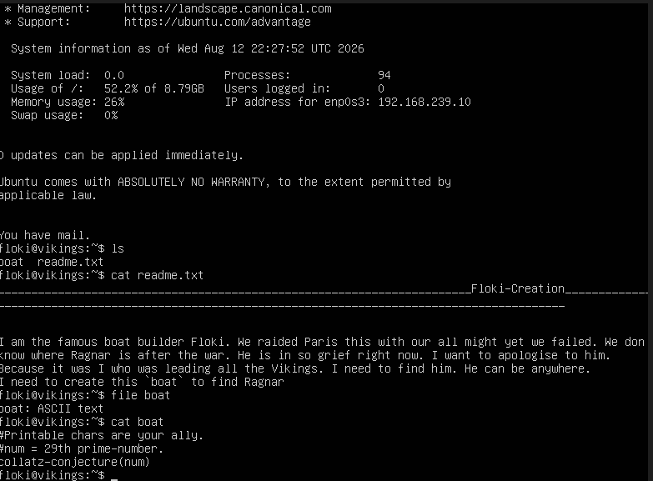
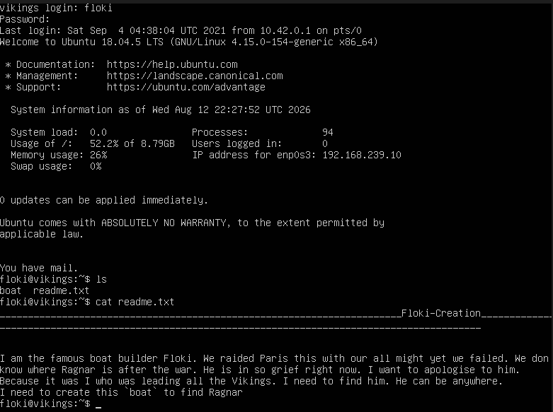
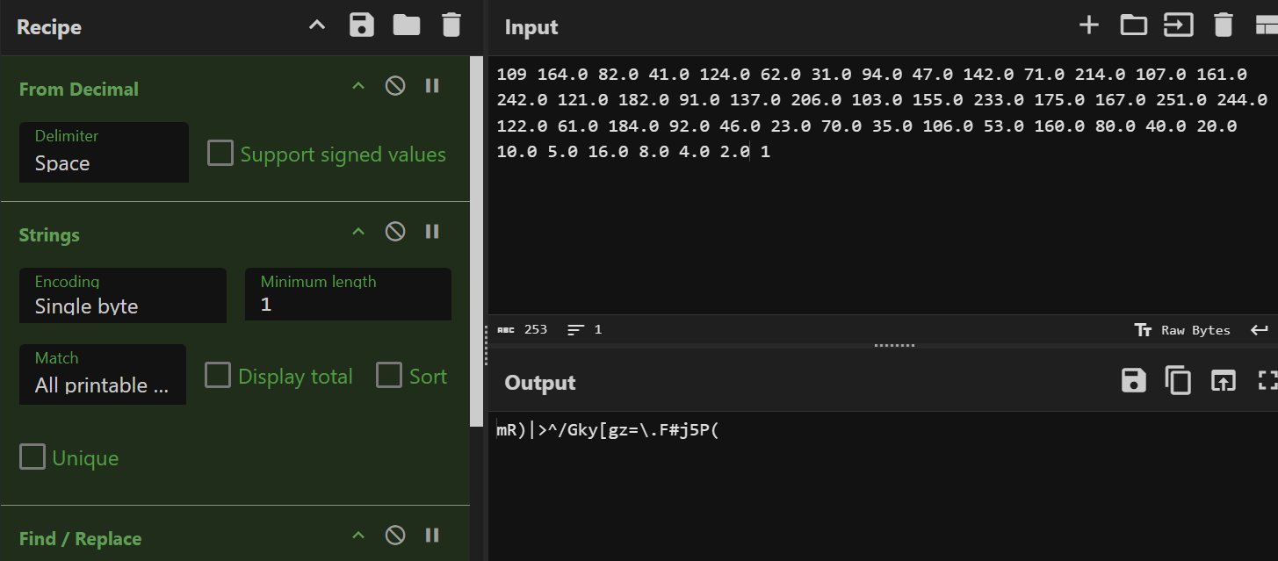
I noticed that floki has LXD permission, so I managed to exploit it using exploit-db code and instructions to perform privilege escalation with the usage of Alpine.
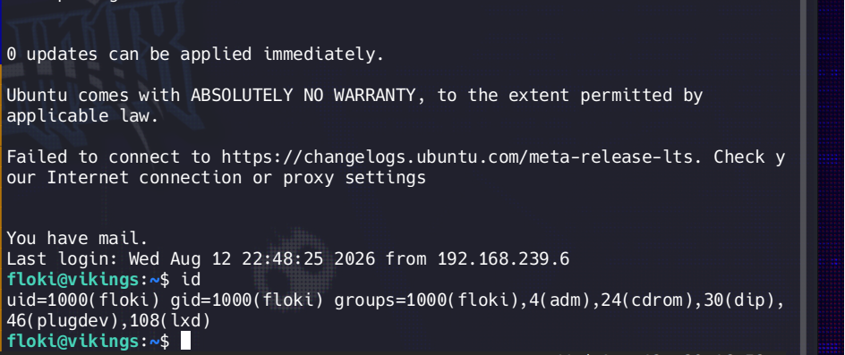
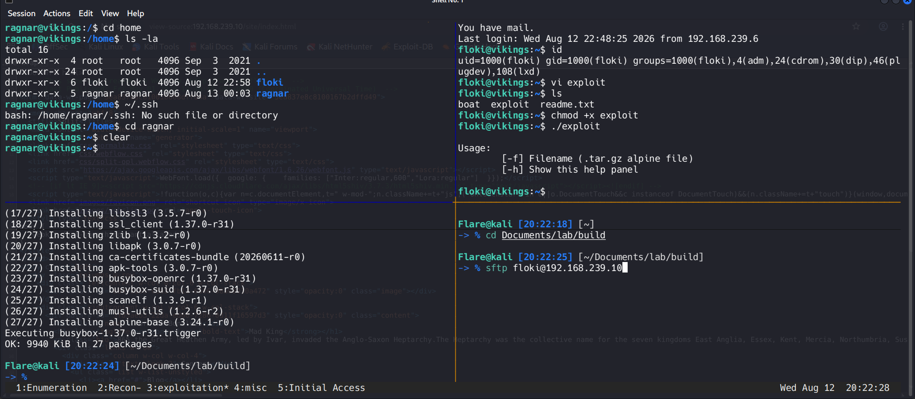
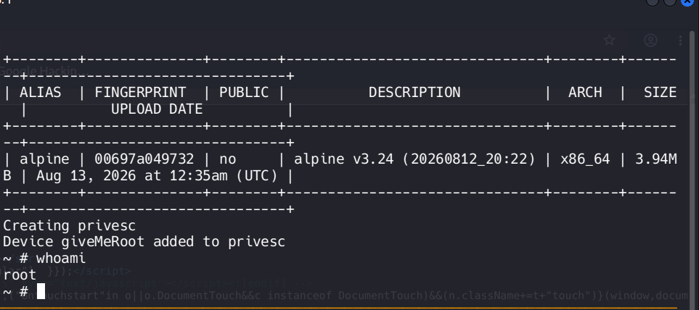
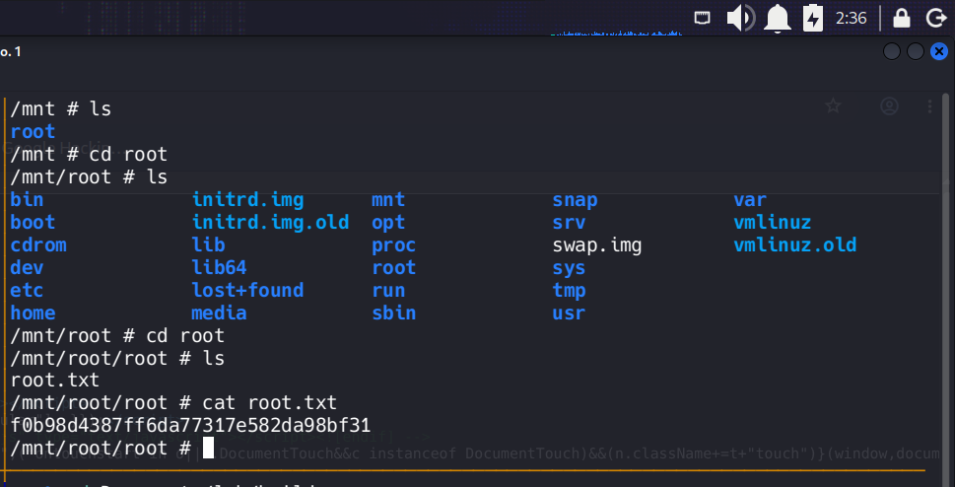

Remediation Summary
As a result of this assessment there are several vulnerabilities ( CWEs ) that are worth noticing and potential CVE, but in this case more like a CWE case. Abusing them led me from an unauthenticated user to a full local privilege escalation.

Mitigation
- CWE-538 + CWE-311 ( Sensitive Data in Accessible Directory ) :
  - Remove the sensitive file from the web-accessible directory. Check the web server for any potential hidden or sensitive files
  - Implementing proper file access policy for web directories
  - Configure the web server to deny access to hidden files
  - Best to never store sensitive data in such directories, no matter what
- CWE-521 ( Crackable Password ) :
  - Enforce strong password for must have archives
  - Use proper encryption instead of zip password protection
  - Implement password policy that prevents use of dictionary words
- CWE-256 + CWE-522 ( Improperly Stored Credentials ) :
  - Never store credentials in files, images or static media that might get exposed
  - Implement a centralized credential management system
  - Use SSH key-based authentication instead of passwords
  - Implement regular password rotations or MFA
- CWE-732 + CWE-284 ( Incorrect Permission Assignment and Access Control ) :
  - Fix permissions for exposed or endangered files
  - Audit all home directories for similar misconfigurations
  - Set restrictive default permissions using umask
  - Consider Access Control Lists for better permission management
- CWE-269 + CWE-250 ( Improper Privilege Management ) :
  - Remove the user from lxd group
  - Audit all group members for such unnecessary privileges
  - Implement the Principle of Least Privilege
  - If LXD is not required, remove or otherwise create a dedicated service account with restricted access

References
- https://cwe.mitre.org/data/definitions/538.html -> CWE 538 page
- https://cwe.mitre.org/data/definitions/311.html -> CWE 311 page
- https://cwe.mitre.org/data/definitions/521.html -> CWE 521 page
- https://cwe.mitre.org/data/definitions/256.html -> CWE 256 page
- https://cwe.mitre.org/data/definitions/522.html -> CWE 522 page
- https://cwe.mitre.org/data/definitions/732.html -> CWE 732 page
- https://cwe.mitre.org/data/definitions/284.html -> CWE 284 page
- https://cwe.mitre.org/data/definitions/269.html -> CWE 269 page
- https://cwe.mitre.org/data/definitions/250.html -> CWE 250 page
- https://www.vulnhub.com/entry/vikings-1,741/ -> Vikings1 Vulnhub page
- https://www.exploit-db.com/exploits/46978 -> Exploit-db page for LXD privilege escalation exploit
- https://gchq.github.io/CyberChef/ -> Cyberchef page
- https://canonical.com/lxd -> LXD documentation

